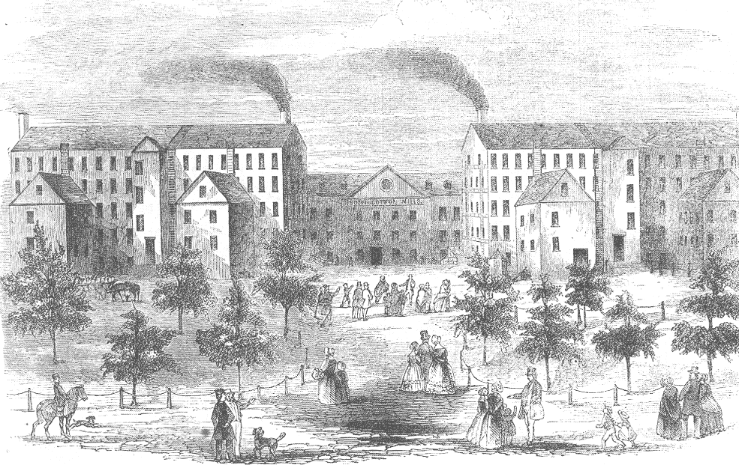
Market Revolution Guided Notes

Directions: Use this guided notes worksheet as a way to organize your notes for the presentation on the market revolution in the United States

Use this space for the quickwrite:
Market Revolution Definition:
The market revolution was a period when:___________________________

________________________, the practice of going into business with little government intervention, expands at an unprecedented level.

Entrepreneurs invested in _____________________to_________________________

Inventions and Inventors
The steamboat was invented by _____________________.

Steamboats led to the creation of ___________________, which are manmade waterways.

Steamboats were heavily used on the _______________ River (not on presentation, but stated by instructor).

By 1830, steamboats were generally replaced by ___________________.

Inventions and Inventors (Continued)
Who invented the telegraph? ______________________

The three main uses for the telegraph were:

1.

2.

3.

Discussion Question: Predict the telegraph’s influence on future communication technology (how did human interaction evolve). Briefly write your answer here in preparation for a class discussion.

The Market Revolution’s effect on Society
What area developed quickly as a result of industrialization?_____________________

Industrialization caused many farmers to move to the _____________ to cultivate the area’s fertile soil.

The work of farmers was cut in half by the _____________ and _________________ (grain harvester).
Changes to the Nation
Describe the economic growth of the US during this time period:

In the early 1800s, only _______% of Americans had manufacturing jobs, but these workers produced goods that were sold nationwide.

North and South were linked by ______________ and East and West were linked by

______________________________.

Changes in the Workplace
How did the rise of industry lead to the downfall of craftsmen and artisans?

Who usually worked in new factories

1.

2.

3. (will be stated on the 3rd and 2nd to last slide)

How did the relationship between worker and employer change?

Changes in the Workplace (Cont.)
Many workers, such as workers of _____________________, attempted to strike for high pay or shorter hours, but, inevitably employers just fired strikers and hired new workers.

_______________ v.___________ established a precedent and made striking constitutional.

Surge in Immigration
From 1845 to 1854, nearly _____________ million immigrants arrived in the United States.

1/3 of the immigrants were from ______________. These immigrants fled their homeland to escape the

hardships of the _______________________.

Exit Slip: Please take out a blank piece of paper and respond to the exit slip on the last slide of the PowerPoint presentation. You will turn this exit slip in for participation points.

